Tweet Sentiment Classification
Xian Zhou
Department of Science, Mathematics and Statistics
DIGI-405: Texts, Discourses, and Data
Dr. Chris T. Teacher
June 5th, 2026

1. Problem Statement

This research investigates how the inclusion of neutral class affects tweet sentiment classification, and what classification errors reveal about ambiguity in microblog-like contexts. Rather than treating sentiment classification as a single fixed task, the analysis compares binary setting with a multi-class setting. The binary task tests polarity separation, while the multi-class task evaluates changes in performance once neutral tweets are included as an analytical category rather than noise. As Kenyon-Dean et al. (2018) argue, difficult sentiment data may not fit neatly into established categories. TF-IDF unigrams and bigrams are considered to capture evaluative words, negation, and emphasis.
The analysis is guided by three sub-questions:
sub_Q1 | Which classifier performs more consistently across binary and multi-class sentiment classification?
sub_Q2 | Which feature set offers the best balance between predictive performance and interpretability?
sub_Q3 | What types of tweets are most frequently misclassified, and what do these errors suggest about label ambiguity?

As a data analyst, the task is to assess not only accuracy, but also how classification errors could distort interpretations of public reactions in social media analysis. Andrejevic (2013) describes platforms such as Twitter as sources of “opinions, reactions, criticism, and praise” (p. 42). In this context, the most serious errors are likely to involve negative tweets being classified as positive or neutral, because these errors may cause complaints or reputational risks to be overlooked. Conversely, neutral tweets classified as polar may exaggerate public satisfaction or dissatisfaction.

Table1. Possible consequences of misclassification in social media sentiment analysis. Start from two misclassification errors for binary task, then extend it to multi-class task with four extra misclassification errors given.
Error Types in the Binary Task
positive tweet classified as negative | Falsely signals backlash or dissatisfaction, making public reaction appear more negative than it is
negative tweet classified as positive | Masks criticism, complaints, or reputational risk, reducing the chance of timely response

Additional Error Types in the Multi-class Task
positive tweet classified as neutral | Underestimates visible support, praise, or campaign approval in the social media conversation
neutral tweet classified as positive | Inflates perceived approval by treating factual or informational posts as public support
negative tweet classified as neutral | Makes complaints or risk signals appear non-urgent, weakening issue detection
neutral tweet classified as negative | Inflates perceived backlash by treating factual reports or neutral mentions as dissatisfaction
These error costs require evaluation metrics that report class-specific performance. Accuracy alone might hide weak performance of smaller or more ambiguous classes. Macro-F1 is therefore used to compare binary and multi-class performance because it gives equal weight to each class, while precision and recall show whether specific classes are over-predicted or under-predicted.

2. Dataset Exploratory Observations
The project uses the tweet_eval sentiment dataset, which contains 59,899 tweets labelled as negative, neutral, or positive. These three labels make the dataset suitable for the project’s comparison between a binary polarity task and a multi-class task that includes neutral tweets as a meaningful category.

2.1. Sentiment label distribution and under-sampling

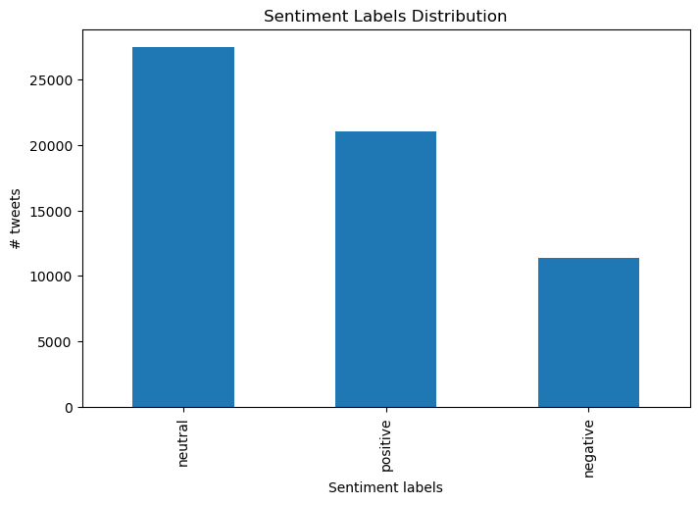
Figure 1. Sentiment label distribution in the tweet_eval dataset, showing neutral and positive labels appear more frequently than negative labels.

Figure 1. shows that the original dataset is imbalanced, with neutral and positive tweets appear more frequently than negative tweets. For model training, the training split was therefore under-sampled to 7,093 tweets per class. However, under-sampling also introduces a limitation because many positive and neutral examples are removed, which may reduce the model’s exposure to varied forms of sentiment expression. The test set was left in its original unequal distribution, so final performance still reflects the realistic class imbalance of the dataset.

2.2. Tweet length and limited context

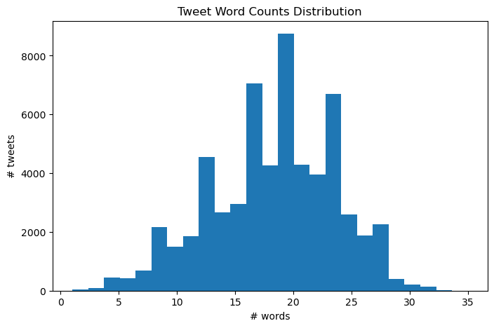
Figure 2. Distribution of tweet word counts in the original dataset. The histogram shows that most tweets are short and provide limited textual context for sentiment classification.

Figure 2. shows that most tweets are short, with the word-count distribution centered around approximately 19-20 words. This characteristic is important because short tweets provide restricted lexical and contextual evidence, resulting in contextual sparseness that is challenging in microblog sentiment analysis (Hutto & Gilbert, 2014). The limited context may also increase label ambiguity, making tweet authors’ sentiment hard to infer.

2.3. VADER compound scores overlap & label ambiguity
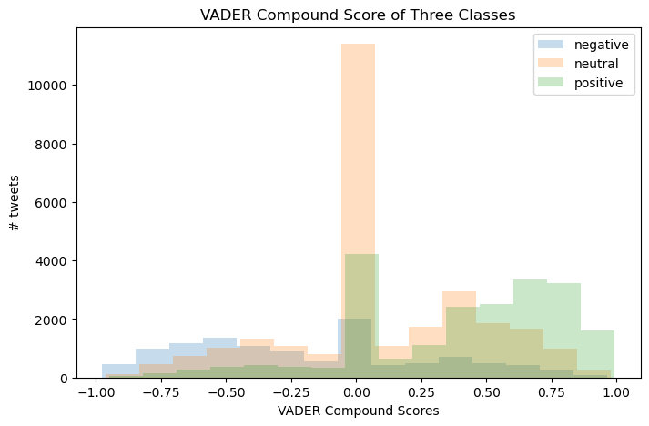
Figure 3. Distribution of VADER compound score across negative, neutral, positive tweets.

Figure 3. displays VADER compound scores distribution across all three categories. The substantial overlap indicates that the three classes are not completely separated. Many tweets cluster around zero, suggesting that classification difficulty is not caused only by class imbalance, but also by tweet-level ambiguity. Neutral tweets may overlap with weakly positive or negative tweets, supporting the project’s focus on neutral class as an analytically meaningful category instead of irrelevant noise.

2.4. Neutral tweet ambiguity

To examine neutral-label ambiguity more closely, four representative neutral tweets were manually inspected. Table 2. provides representative examples of four neutral-label ambiguity patterns. These examples show that neutral tweets may involve factual reporting, weak, mixed sentiment, or missing context, which later misclassifications may reflect as category ambiguity rather than simple model failure.

Table 2. The table presents how the neutral tweets expressed unclearly with representative tweets selected from exploratory analysis.

Factual tweets | (train_91) The Hitchhiker's Guide to the Galaxy Game - 30th Anniversary Edition Need to sign up with the BBC online.
Why ambiguous: reporting information about an anniversary version of game but is devoid of certain emotion
Weak sentiment | (train_9271) @user @user @user i wouldn't be that harsh. she may exploit holes in Rousey's standup game. ...maybe.
Why ambiguous: carrying cautious judgement without emotional intensity. Phrases “ I wouldn't be that harsh”, “may”, and “maybe” mollified the sentiment.
Mixed sentiment | (train_9038) I admire Hillary &amp; may even vote for her. But she so doesn't sound sorry. #email server
Why ambiguous: containing conflicting emotional orientations as it simultaneously shows positive and negative attitude toward Hillary.
Context dependent | (train_15462) @user true, but she was flapping her gums, I'm glad Nicki sat her down. Someone needed to show her what she said was foul."
Why ambiguous: accounts on missing conversational context, the speaker did not mention who “she” refers to, what “she” was talking. It’s unclear by missing the surrounding text.

3. Model
3.1 Classification Algorithms Design

Pipeline# | Classification algorithm | Feature combinations | Purpose
1 | Logistic regression | Token + POS + Lexicon | Logistic regression baseline using interpretable sentiment and linguistic features
2 | Logistic regression | Token + POS + Lexicon + Embeddings | Test whether semantic embedding features improve logistic regression baseline performance
3 | Decision Tree | Token + POS + Lexicon | Extra algorithm comparison with the same baseline feature set of pipeline1
4 | Decision Tree | Token + POS + Lexicon+ Embeddings | Extra algorithm comparison with the same extended feature set of pipeline2

Table 3. Classification pipelines setting designed for binary and multi-class tweet sentiment analysis. The four selective pipelines compare the logistic regression and decision tree classifiers under two features combinations (highly interpretable linguistic features and another extended one with embeddings) help to explore the sub-questions.

Table 3. summarises the pipelines used for both binary and multi-class tasks, allowing two settings to be compared under the same model design. Since tweets are short, sparse, informal, and frequently abbreviated, sentiment evidence may appear in multiple forms rather than in direct evaluative words alone (Hutto & Gilbert, 2014). The pipelines therefore combine token, POS, VADER lexicon, and embedding features.
Logistic regression was selected as the main baseline because it suits high-dimensional sparse text features and remains interpretable through feature weights. Decision tree was included as a contrasting classifier because it uses rule-like splits rather than weighted combinations. Applying both algorithms to the same feature sets allows a fair comparison across task settings.
This pipeline design creates a fair comparison across three dimensions:
Task setting | binary vs multi-class
Model feature design | with and without embeddings feature
Model algorithmic design | logistic regression vs. decision tree

3.2 Preprocessing

Preprocessing was designed to preserve useful sentiment signals. For token features, TF-IDF functioned to weight terms depend their distinctiveness across the tweet collection. The maximum number of token features was increased to 700 to retain a wider vocabulary choice while simultaneously controlling feature-space size. Tokens were also required to appear in at least two tweets, reducing the influence of one-off terms unlikely to generalise. The n-gram range included unigrams and bigrams, allowing the model to capture both individual sentiment cues and short phrases, including negation and intensifiers. As Table 4. shows, a customised stop-word list was designed to dismiss less informative terms while retaining negation such as “not”, “no”, and “n’t”. The preprocessing settings tested whether preserving tweet-specific sentiment cues, including less frequent but repeated evaluative terms, negation, and short phrases, improved classification performance.

Table 4. customised stop words list with corresponding functions designed for both binary and multi-class classification task.

Python notebook 3.1 caution_stop_words
Preserved forms | Purpose and function of Preservation
not | Preserve direct negation, e.g., “not good”
no | Preserve denial, e.g., “no support”
never | Preserve strong negation, e.g., “never again”
nt | Preserve informal negation, e.g., “dont”, “cant”
n’t | Preserve contracted negation, e.g., “don’t”, “can’t”
ever | Preserve intensified negation, e.g., “worst ever”
ca | Preserve full negation if model only keeps “n’t”

3.3 Feature Sets Design

Pipeline 1 combined token, POS, and VADER lexicon features as an interpretable baseline. Token features capture surface-level sentiment evidence, including sentiment-bearing words, symbols, and punctuation such as “love”, “:-)” and “!”. POS features capture grammatical evidence. VADER was selected because it is designed for microblogging contexts and accounts for negation, degree modifiers, and contrastive conjunctions (Hutto & Gilbert, 2014). Pipeline 2 added embeddings to test whether semantic similarity helps classify tweets that express similar sentiment with different vocabulary. Pipelines 3 and 4 repeated these feature sets with decision tree classifier to ensure a fair algorithm comparison using comparable inputs.

4.Results

4.1 Binary Classification Performance
Table 5. Binary classification (positive and negative) performance across four pipeline settings. Accuracy and macro-F1 report overall performance. Precision and recall show reliably each pipeline detects each sentiment polarity.
Pipeline | Precision | Recall | Accuracy | macro-F1 | Main Findings
Pipeline 1 | Negative 0.633  Positive 0.927 | Negative 0.830  Positive 0.817 | 0.821 | 0.793 | - Baseline binary-class performed higher than expectation  - Positive tweets are classified more reliably than negative tweets  - Most interpretable with visible class-specific features
Pipeline 2 | Negative 0.690  Positive 0.940 | Negative 0.856  Positive 0.853 | 0.854 | 0.829 | - Strongest-preforming model overall  - Embeddings improve both classes, especially negative F1  - Hard to interpret embedding features under abstract numeric dimensions
Pipeline 3 | Negative 0.484  Positive 0.882 | Negative 0.756  Positive 0.692 | 0.710 | 0.683 | - Decision tree baseline performed worse than Logistic Regression
Pipeline 4 | Negative 0.526  Positive 0.873 | Negative 0.712  Positive 0.756 | 0.744 | 0.708 | - Decision tree performed worse than logistic regression under same features  - Embedding features were also hard to interpret for the decision tree pipeline

Table 5. reports the binary classification results for positive and negative tweets. Pipeline 2 achieved the strongest binary performance, with accuracy of 0.854 and macro-F1 of 0.829. Although class-level F1 scores are provided in Appendix A rather than Table 5. to keep the comparison readable, they show where improvement occurred. Compared with Pipeline 1, Pipeline 2 increased negative F1 from 0.718 to 0.764 and positive F1 from 0.868 to 0.894, suggesting that embeddings added useful semantic information for distinguishing polarity. Pipeline 2 also produced balanced recall, with negative recall at 0.856 and positive recall at 0.853. However, positive F1 remained higher than negative F1, indicating that negative tweets were harder to classify reliably. Overall, decision tree classifier remained weaker than logistic regression.

4.2 Multi-class Classification Performance
Table 6. Multi-class classification (negative, neutral, positive) results across four pipelines designed in part 3.

Pipeline | Precision | Recall | Accuracy | macro-F1 | Main Findings
Pipeline1 | Negative 0.420  Neutral 0.656  Positive 0.708 | Negative 0.696  Neutral 0.543  Positive 0.659 | 0.615 | 0.600 | - Logistic regression baseline performance was lower in multi-class task than in the binary task  - Including neutral category brings challenges for the classification task  - Positive tweets can be predicted easier in both task settings
Pipeline2 | Negative 0.442  Neutral 0.676  Positive 0.721 | Negative 0.731  Neutral 0.560  Positive 0.673 | 0.633 | 0.620 | - Strongest-preforming model overall  - Logistic regression extended with embeddings improved all precision and recall scores compared to baseline model  - Neutral and negative are still harder to classify than positive
Pipeline3 | Negative 0.412  Neutral 0.634  Positive 0.599 | Negative 0.474  Neutral 0.484  Positive 0.714 | 0. 577 | 0.547 | Baseline in decision tree struggled especially with negative tweets
Pipeline4 | Negative 0.436  Neutral 0.592  Positive 0.615 | Negative 0.446  Neutral 0.557  Positive 0.648 | 0.577 | 0.549 | - Decision tree with embeddings improved neutral recall but reduced positive recall  - Decision tree with embeddings weakened neutral precision but improved negative and positive precisions  - Overall performance remained weaker than logistic regression

Table 6. reports the multi-class results after neutral tweets were included. Performance dropped across all pipelines, showing that neutral tweets made classification harder. Pipeline 2 remained strongest, with accuracy of 0.633 and macro-F1 of 0.620. The macro-F1 ranking was consistent with the binary task: Pipeline 2, Pipeline 1, Pipeline 4, then Pipeline 3, suggesting stable relative comparisons between feature sets and algorithms. However, embeddings improved performance without removing neutral-class difficulty. Class-level scores explain this drop: positive tweets remained most stable, negative tweets had higher recall than precision, and neutral tweets had higher precision than recall. This suggests many true neutral tweets were pulled into polar classes, supporting the project’s focus on neutral-label ambiguity.

4.3 Task-framing Comparison
Pipeline | Binary macro-F1 | Multi macro-F1 | Difference after including neutral class | Main Findings
Pipeline1 | 0.793 | 0.600 | -0.193 | - Including neutral class lowered the baseline performance  - Extra class brings extra boundary for classification
Pipeline2 | 0.829 | 0.620 | -0.209 | - Largest drop on performance  - Remain as the strongest pipeline  - Embeddings help both the settings (binary & multi-class)  - Embeddings cannot solve language ambiguity from neutral class
Pipeline3 | 0.683 | 0.547 | -0.136 | - Decision tree model perform worse after including the neutral class  - Struggle with neutral class from both task settings
Pipeline4 | 0.708 | 0.549 | -0.159 | - Embeddings feature slightly improved decision tree  - Performance remain weak with or without neutral class
Table 7. Change in macro-F1 after including the neutral class. Difference is calculated with multi-class macro-F1 deduct binary class macro-F. Negative values represent the drop in performance after including neutral class.

Table 7. compares macro-F1 across binary and multi-class tasks. Every pipeline performed weaker after neutral tweets were included, especially with Pipeline 2 receiving the largest performance drop of 0.209 as highlighted. However, higher binary scores cannot be treated as proof that binary classification is analytically superior. They partly reflect the absence of neutral tweets, where most of the label ambiguity is concentrated. This aligns with Kenyon-Dean et al.’s (2018) argument that difficult sentiment cases should not be treated as noise, since models still have to encounter tweets that cannot neatly fit into the established categories.
Pipeline 2 remained the strongest across both settings, indicating that embeddings improved performance across both task settings but were unable to resolve neutral-class ambiguity. Overall, the comparison supports the project’s main claim, that the neutral class is a difficult but meaningful category that exposes unstable boundaries between polar and non-polar sentiment.

5. Discussion
5.1 Classifier and feature set interpretation
The results answer the first two sub-questions by showing a trade-off between predictive performance and interpretability. The algorithm comparison answers the first sub-question. Logistic regression classified more consistently across both binary and multi-class settings, as Pipelines 1 and 2 outperformed the decision tree pipelines in both tasks. The feature set comparison addresses the second sub-question. Pipeline 2 achieved the strongest predictive performance because embeddings improved both binary and multi-class results. However, embeddings were difficult to interpret because they appeared as abstract numerical dimensions, such as embeddings_emb_#, rather than visible language cues. In contrast, Pipeline 1 performed slightly lower but provided stronger interpretability. Therefore , embeddings improved prediction, but the token, POS, and VADER feature set offered the best basis for explaining classification errors.

Table 8. Representative interpretable features from Pipeline 1 across binary and muti-class tasks, showing how token, POS, and lexicon features capture sentiment polarity, discourse context, and linguistic structure visibly.
Feature type | Examples of Pipeline 1 | Helps capture
Lexicon | lexicon__positive, lexicon__negative | sentiment polarity  emotional orientation
Token | amazing, Happy, hate, worst, fuck, :(, :), !, not, n’t, named entities | token cues  negation  symbols  punctuation  emoticons  topic-specific terms
POS | Pos_PROPN | syntactic structure

5.2 Binary misclassification patterns
Binary errors were not random: Pipeline 1 misclassified 53 negative tweets as positive and 150 positive tweets as negative. This imbalance suggests that some positive tweets were pulled toward the negative class when they contained negative surface cues. As Table 9. shows, one positive tweet was misclassified as negative because the word “failed” contributed strong negative evidence, even though the tweet expressed a broader positive evaluation. Conversely, a negative tweet was misclassified as positive when terms such as “Foo Fighters” and “best” carried strong positive feature weights.
Misclassification type | Negative → Positive | Positive → Negative
Sample tweet | (test_52) Judging by the traffic and complaining, I think I might be best setting for Foo Fighters' Milton Keynes gig tomorrow right now | (test_25) I love how Thanksgiving break had hella bangers and we're in the 2nd week of winter break and have failed to have one yet
Feature score | tokens__Foo Fighters: 12.85  tokens__best: 5.32  lexicon__positive: 1.13 | lexicon__negative: 1.66
Table 9. Representative binary classification examples from Pipeline 1, feature scores row shows how specific words with high score can override the original sentiment.

These examples show that even binary polarity labels can be unstable when sentiment depends on context rather than direct sentiment words. The binary task therefore worked as a useful controlled polarity test, but it was less suitable for understanding the full complexity of tweet labelling.

5.3 Neutral class ambiguity and difficult tweet types
Table 10. Confusion matrix for Pipeline 1 in multi-class task, showing that neutral tweets were more often confused with negative class. This indicates unstable boundaries between the three classes.
Predicted true | Negative | Neutral | Positive
Negative | 217 | 58 | 37
Neutral | 211 | 472 | 186
Positive | 89 | 190 | 540

The multi-class task more directly answers the third sub-question because it shows which tweets were difficult to classify and what those errors reveal about label ambiguity. Table 10. shows the confusion matrix of Pipeline 1, 211 true neutral tweets were predicted as negative, and 186 were predicted as positive. This bidirectional misclassification pattern suggests that neutral tweets do not simply represent an absence of sentiment. Alternatively, they often contain surface cues which resemble polar sentiment, making the boundary between neutral and polar categories unstable.
Table 11. Neutral tweets misclassified as negative from Pipeline 1 in multi-class task. This table shows how event-related words pulled neutral tweets toward negative class despite their informational function.
neutral INCORRECTLY CLASSIFIED as: negative | Surface cue leading to negative prediction
( test_9 )Irving Plaza NYC Blackout Saturday night… | Event word predicted as negative
( test_34 ): …Restoration of the damaged side of the Anna arch begin on Wednesday,… | Problem word predicted as negative
( test_1936 ) Digne and Falque caused Juventus real problems… | Negative word
( test_1996 ) Harper’s Worst Offense against Refugees … | Strong negative word

From Table 11., neutral tweets misclassified as negative often appeared factual or event-reporting. For example, the tweet about the Irving Plaza NYC “Blackout” was labelled neutral, but the event itself has negative associations. The blackout affected a large area from Times Square to the Upper West Side and left around 73,000 customers without power for several hours (Associated Press, 2019). Similarly, the Anna arch tweet reported repair work on a landmark, but words such as “restoration” and “damaged” may have led the model to detect negative sentiment. Because the Anna arch was a landmark, the tweet functions more as an informational update than negative stance (Express News Service, 2012). Other neutral tweets contained negative cues such as “problems” and “worst” while reporting issues rather than dissatisfaction. These cases show how factual tweets can be pulled toward the negative class when event-related words carry negative polarity.

Table 12. Neutral tweets misclassified as positive from Pipeline 1 in multi-class task. This table shows how promotional-related words pulled neutral tweets toward positive class despite their informational function.
neutral INCORRECTLY CLASSIFIED as: positive | Surface cue leading to positive prediction
( test_47 )…selling 4 tickets for …concert…$100 a piece. Dm me if interested! | Concert ticket promotion, “interested” creates positivity which brings event enthusiasm
( test_1983 ) …Do u want to get iPh0ne 6 for FREE? U better check my bi0. Thx | Capitalised “FREE”, abbreviated “thx” may appear positive

From Table 12., neutral tweets misclassified as positive often had a different pattern: they contained promotional or opportunity-based language. Tweets for selling tickets or advertising a free phone were labelled as neutral because their main function was informational or promotional. Nevertheless, words “interested”, capitalised “FREE”, and “Thx” may signalled engagement, opportunity, or politeness to the classifier. These cues may not directly express a clear positive attitude, but they can resemble positive sentiment.
The misclassification pattern suggests that the main labelling problem is category ambiguity rather than simple annotator error. Short tweets can perform several discourse functions at once, so neutral tweets may contain positive or negative surface cues while still functioning as factual, promotional, mixed, or context-dependent texts. Context scarcity can create ambiguity, supporting Kenyon-Dean et al.’s (2018) argument that difficult sentiment cases may not neatly fit into established categories. Therefore, neutral tweets are not always sentiment-free. This aligns with the project’s core argument that the neutral class is not irrelevant noise, but a methodologically significant category that reveal unstable boundaries between polarities. Therefore, the most difficult tweets contained ambiguous surface cues but did not match the broader discourse function.

5.4 Evaluation metrics and costs
The evaluation metrics show why accuracy alone is insufficient for this project. Macro-F1 was necessary because it weights each class equally, preventing stronger classes from hiding weak performance on ambiguous classes. In the multi-class task, neutral recall was low, meaning many true neutral tweets were classified as positive or negative. In an social media monitoring context, this could exaggerate public satisfaction or dissatisfaction. Negative tweets also showed higher recall than precision, meaning the model detected many negative tweets but also over-predicted negativity. This could make organisations overestimate dissatisfaction or reputational risk.

5.5 Limitations Discussion
Several limitations affect the generalisability of the findings. First, the original dataset and test set were imbalanced. Under-sampling reduced majority-class bias in training, but it also removed many positive and neutral examples that may have contained useful variation. Neutral is the largest class, this may have especially reduced exposure to varied neutral examples, limiting the research’s focus on neutral-label ambiguity. Second, the project used baseline classifiers and feature sets, so the results show comparative behaviour rather than maximum possible performance. Third, the strongest model, Pipeline 2, reduced interpretability because embedding features were difficult to connect to specific language cues. Finally, the manual error analysis focused on selected examples, so it illustrates likely patterns of ambiguity rather than providing a complete typology of all misclassifications. In this dataset, binary polarity classification improved scores, but including neutral class revealed the ambiguous cases that real-world classifiers still need to handle.
Overall, the results show that including the neutral class lowers classification performance, but also produces a more realistic and analytically useful task. The neutral class revels tweets that are challenging to label, including factual, weak, promotional, mixed, and context-dependent tweets. This implies that the multi-class classification task is comparatively more difficult not simply because it excludes an extra category, but because it preserves many ambiguous cases that binary classification may filters out.

Appendix A.
Table 1. Class-level F1 scores across binary and multi-class pipelines.

Task | Pipeline # | Negative F1 | Neutral F1 | Positive F1
Binary | 1 | 0.718 | ------- | 0.868
Binary | 2 | 0.764 | ------- | 0.894
Binary | 3 | 0.590 | ------- | 0.776
Binary | 4 | 0.605 | ------- | 0.810
Multi-class | 1 | 0.524 | 0.594 | 0.683
Multi-class | 2 | 0.551 | 0.613 | 0.696
Multi-class | 3 | 0.441 | 0.549 | 0.651
Multi-class | 4 | 0.441 | 0.574 | 0.631

References
Andrejevic, M. (2013). Emotional glut: Opinion mining and sentiment analysis. In Infoglut: How too much information is changing the way we think and know (pp. 42–61). Taylor & Francis Group.
Associated Press. (2019, July 13). Thousands left in the dark during NYC power outage. PBS NewsHour. https://www.pbs.org/newshour/nation/nyc-power-outage-knocks-out-subways-businesses-elevators
Express News Service. (2012, August 29). Bid adieu to city’s landmark arch in a day or two. The New Indian Express. https://www.newindianexpress.com/cities/chennai/2012/Aug/29/bid-adieu-to-citys-landmark-arch-in-a-day-or-two-401253.html
Guardian sport. (2026, May 20). Aaron Rodgers says 2026 will be his final NFL season: “This is it”. The Guardian. https://www.theguardian.com/sport/2026/may/20/aaron-rodgers-final-season-steelers-retire
Hoosier, A. (2020, March 13). Harry Styles dons Packers jersey for Tiny Desk Concert on NPR. Green Bay Packers. https://www.packers.com/news/harry-styles-dons-packers-jersey-for-tiny-desk-concert-on-npr
Hutto, C. J., & Gilbert, E. (2014). VADER: A parsimonious rule-based model for sentiment analysis of social media text. In Proceedings of the Eighth International AAAI Conference on Weblogs and Social Media (pp. 216–225). Association for the Advancement of Artificial Intelligence.
Kenyon-Dean, K., Ahmed, E., Fujimoto, S., Georges-Filteau, J., Glasz, C., Kaur, B., Lalande, A., Bhanderi, S., Belfer, R., Kanagasabai, N., Sarrazingendron, R., Verma, R., & Ruths, D. (2018). Sentiment analysis: It’s complicated! In Proceedings of the 2018 Conference of the North American Chapter of the Association for Computational Linguistics: Human Language Technologies (pp. 1886–1895). Association for Computational Linguistics.

